HAWKHURST NEIGHBORHOOD DEVELOPMENT PLAN
JANUARY 2023 VISIONING EVENT
CONSULTATION OUTPUT REPORT
JULY 2023
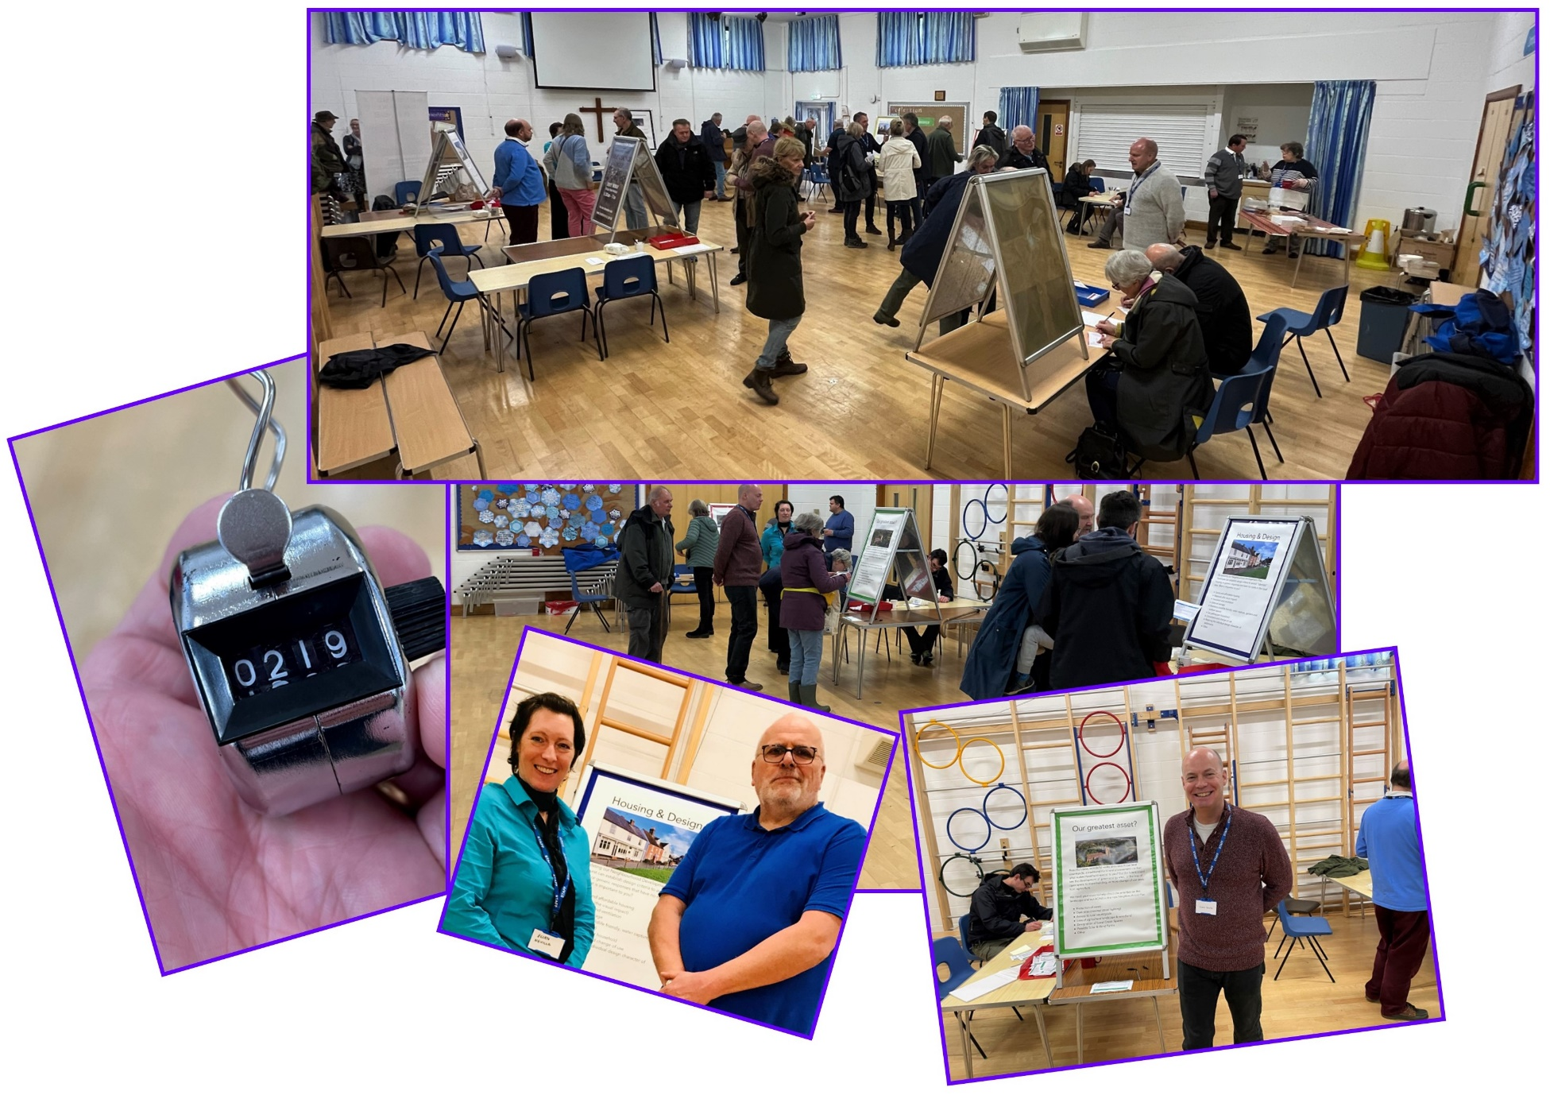

- INTRODUCTION AND CONTEXT

  - The existing Hawkhurst Neighbourhood Development Plan (“the HNDP”) was adopted by Tunbridge Wells Borough Council (“TWBC”) on 26 March 2018.

  - Following discussions with TWBC officers the HNDP was reviewed and formally modified in April 2020. The HNDP (as modified) remains extant and forms part of the statutory development plan for the purpose of the determination of planning applications within the Parish of Hawkhurst.

  - The HNDP (as modified) was prepared against the background of the existing TWBC Development Plan comprising:

- Saved Policies from the 2006 Local Plan;
- The 2010 Core Strategy Development Plan Document; and
- The 2016 Site Allocations Local Plan

  - In 2017 TWBC commenced preparation of a new Local Plan to replace the existing Development Plan Documents and to form the basis for determining the suitability of development proposals across the Borough to 2038.

  - The draft replacement Local Plan evolved over the course of its preparation and consultation stages. Whilst a number of proposed site allocations within Hawkhurst were removed at the Regulation 19 stage, a smaller number were retained.

  - TWBC submitted the revised Local Plan (2020-2038) for public examination in October 2021. The Examination-in-Public took place over the course of the summer of 2022.

  - Following the conclusion of the Examination-in-Public, the Inspector issued his initial findings in November 2022. He concluded that the new Plan was not “sound” and identified three options for TWBC to consider to take the new Local Plan forward – all of which required TWBC to undertake significant additional work.

  - As at the date of this Report, it is anticipated that TWBC will publicly resolve how it intends to proceed in summer 2023 following which it is likely there will be further public consultation on proposed modifications to the draft Local Plan.

  - In parallel with the preparation of the replacement TWBC Local Plan a number of major planning applications have been approved within Hawkhurst since the adoption of the HNDP. All of the proposed housing allocations within the replacement plan have already been granted planning permission.

  - In turn further changes are proposed to the planning system at a national, local and neighbourhood level through both the Levelling-Up and Regeneration Bill and amendments to the National Planning Policy Framework.

  - Against this background Hawkhurst Parish Council (“the Parish Council”) decided to commence the preparation of a new replacement Neighbourhood Development Plan to ensure consistency with the new TWBC Local Plan and to enshrine the priorities and objectives for the Village over a plan period to 2038 – “the New HNDP”.

  - The Parish Council formed a Steering Group to take forward to preparation of the New HNDP. The Steering Group is comprised of representatives from the Parish Council, a local TWBC Ward Member and a number of residents of the Parish.

  - In late 2022, the Steering Group formulated an overall Project Plan and a specific Consultation and Engagement Strategy to guide the preparation of the New HNDP.
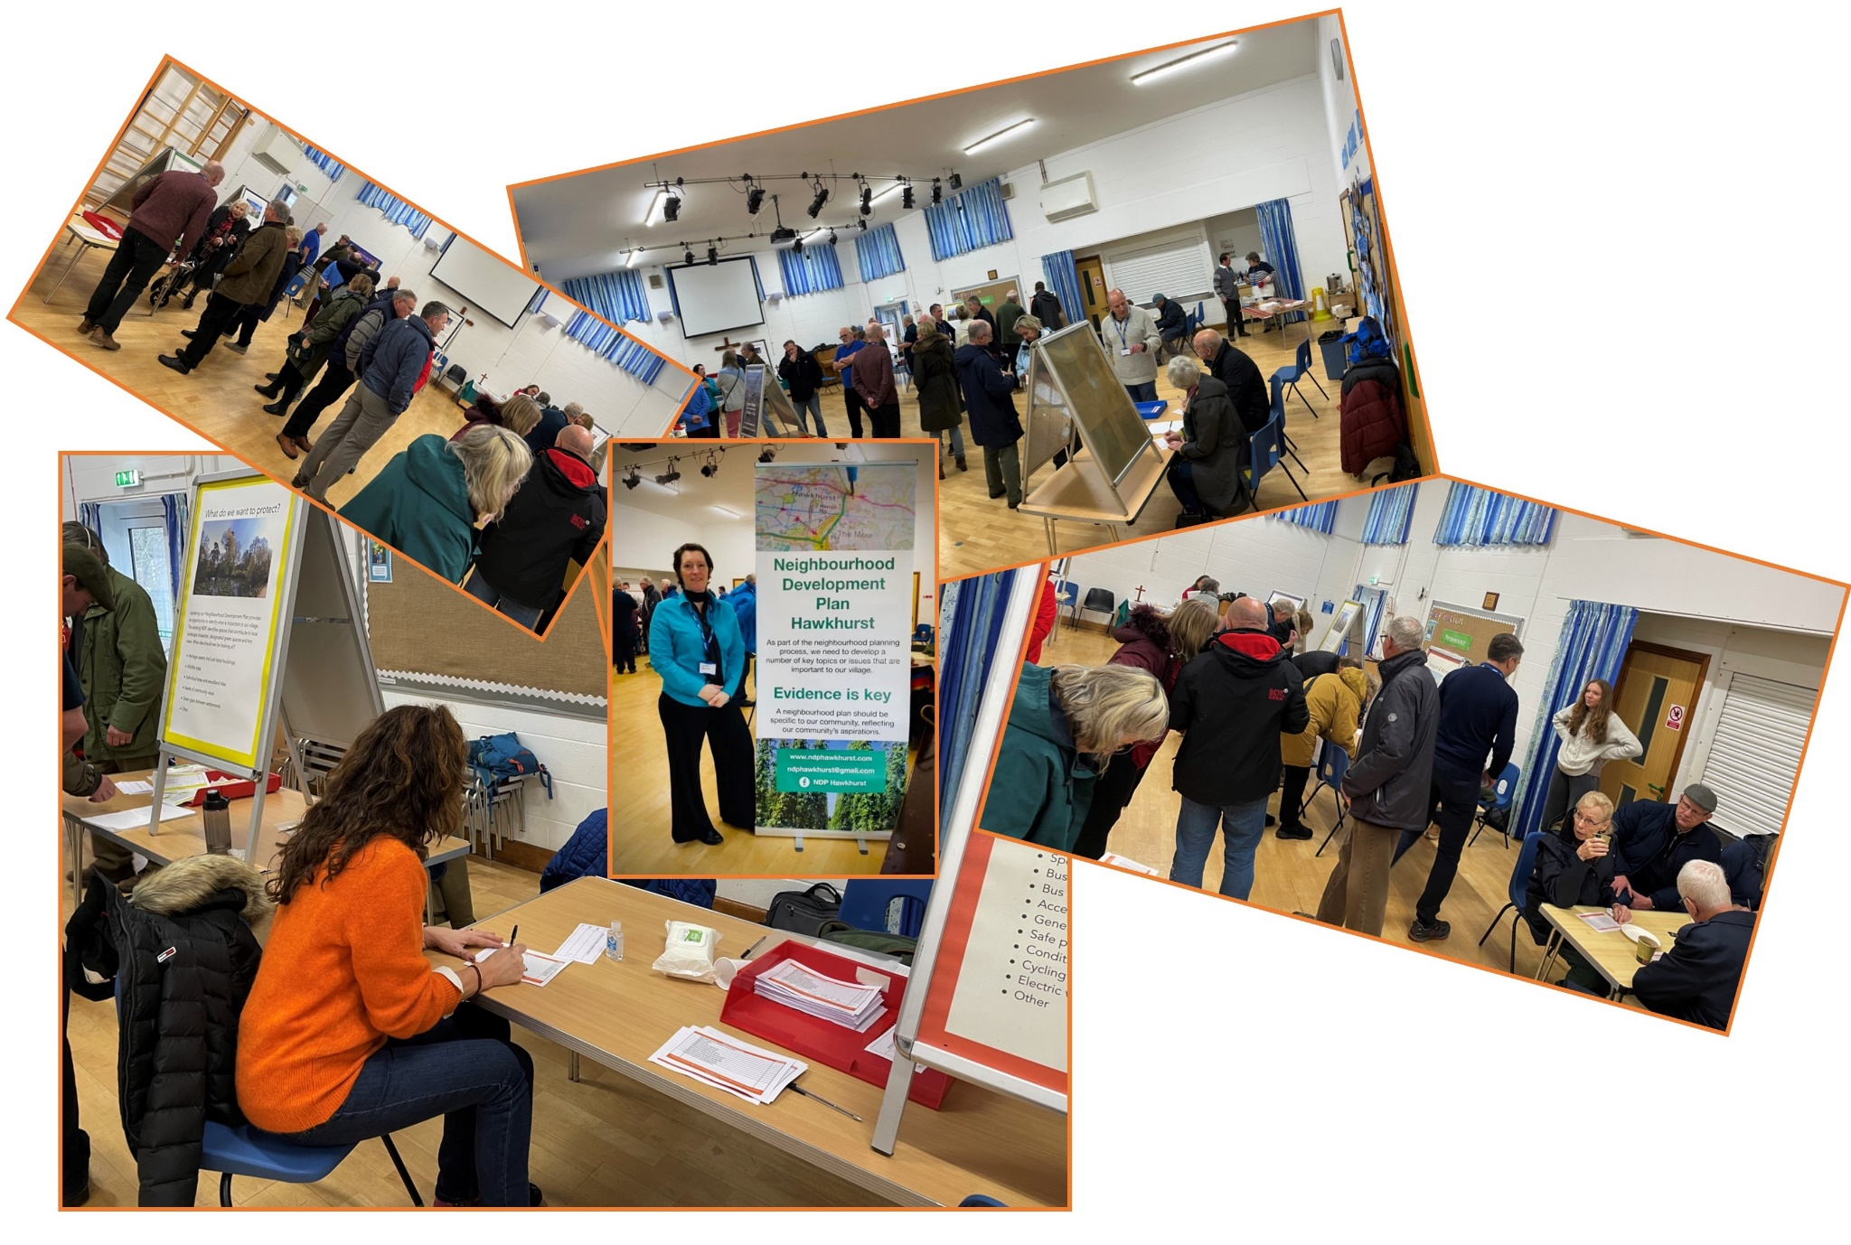

- THE VISIONING EVENT

  - The Consultation and Engagement Strategy proposed that at Phase 2 of the Project, a public event be held which would provide an opportunity for residents to set out their priorities for the Village – the Visioning Event.

  - The results of the Visioning Event would inform the formation of the Vision for the New HNDP, and guide the prioritisation of policies..

  - A date for the Visioning Event was originally programmed for September 2022 but was postponed following the death of Queen Elizabeth II. A revised date was identified for 14 January 2023.

  - Hard copy invitations to the Visioning Event were hand delivered to all residences and business premises within the Village in late December 2022 and early January 2023. In turn the Visioning Event was advertised across social media channels and the Steering Group’s own Neighbourhood Plan Website.

  - The Visioning Event was held on 14 January 2023 at Hawkhurst CofE Primary School between 10.00am and 3.00pm.

  - Prior to the Visioning Event, the Steering Group identified 6 overarching ‘Themes’:

- What do we want to protect?
- Housing and Design
- Our Community
- Our Greatest Assets
- Economy and Infrastructure
- Transport and Access

  - Within each ‘Theme’ a series of ‘Issues’ were identified on which residents’ views would be canvassed.

  - At the Visioning Event a station was set up for each Theme with a poster setting out the identified Issues. Each station was staffed by members of the Steering Group for the duration of the Visioning Event, to explain the Theme and identified Issues, answer any questions from residents, and to record their comments.

  - Scorecards were prepared for each Theme which listed the individual Issues. Attendees were invited to complete the scorecards and identify which Issues they considered to be of the highest priority for the Village. They were invited to score the issues they considered to be of High (“H”), Medium (“M”) or (“Low”) importance – or leave blank if they felt the issue was of no importance at all. Residents were encouraged to try to focus their responses to the issues of the most importance to them.

  - In addition, the scorecards contained a blank summary box where attendees were invited to record any specific comments they wished to raise.

  - Finally, attendees were advised of the opportunity to volunteer to join specific Working Groups to assist in preparation of the New HNDP. Forms were available at each station to enable volunteers to confirm their contact details and areas of specific interest.
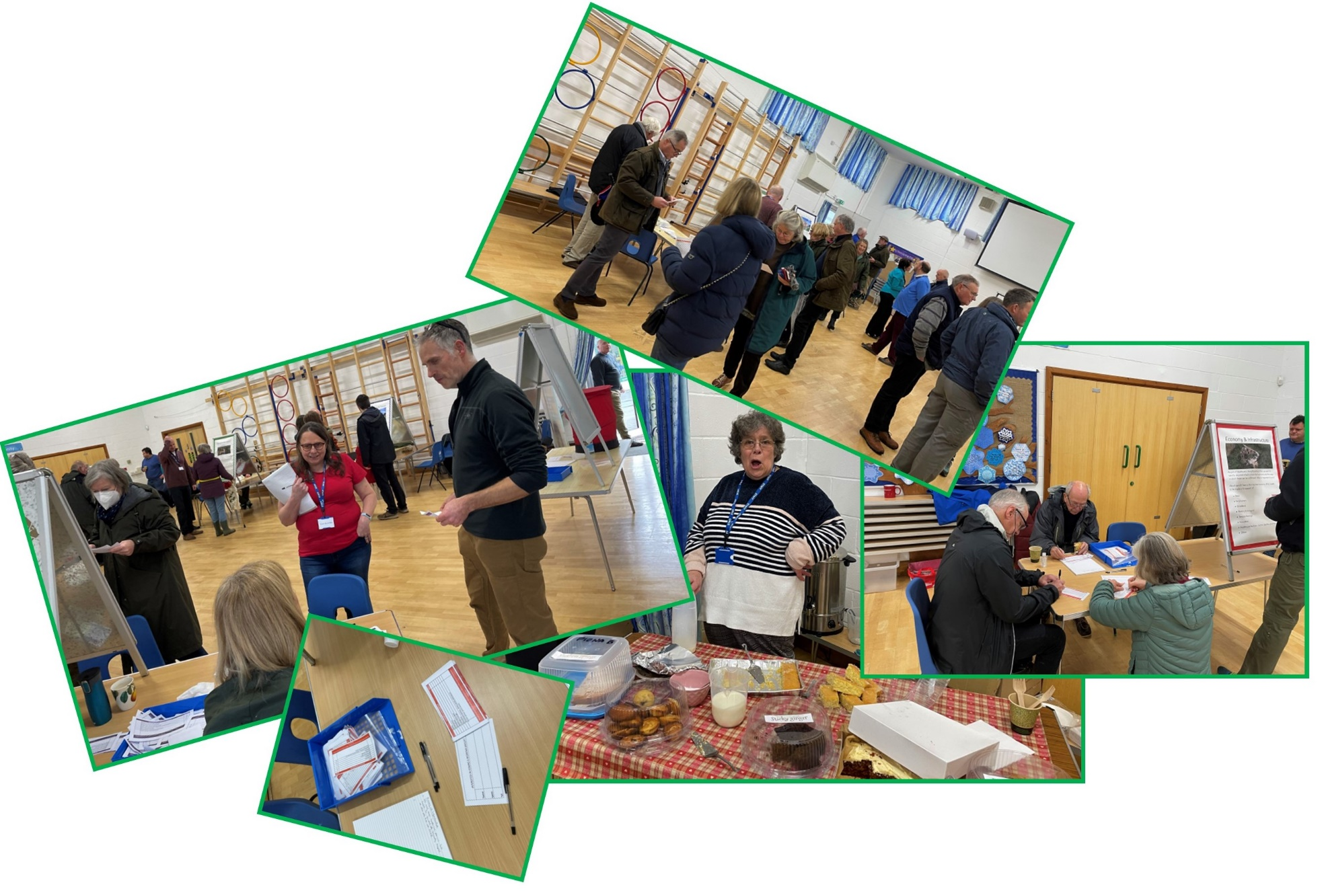

- THE RESULTS

  - The Visioning Event was attended by 230 people.

  - The data from the completed Scorecards is set out in the Tables below for each Theme and Issue.

  - The tables record the ‘raw’ number of High, Medium, Low or Not Rated scores for each Issue within each Theme.

  - In turn, to assist with comparison processes across the Themes, an adjusted standardised score was added attributing each High score with 3, each Medium with 2, each Low with 1 and each Not Rated as 0. The adjusted standardised scores are shown adjacent to the Raw Scores. The cumulative adjusted score is then set out followed by a standardised percentage score as against the maximum potential score of all highs from all attendees.

What do we want to protect?

Issue | Raw High | Adjusted High | Raw Medium | Adjusted Medium | Raw Low | Adjusted Low | Raw Not rated | Adjusted Not Rated | Adjusted Cumulative Score | Standardised Percentage Score
Heritage assets | 98 | 294 | 52 | 104 | 6 | 6 | 10 | 0 | 404 | 58.55%
Wildlife sites | 142 | 426 | 17 | 34 | 1 | 1 | 6 | 0 | 461 | 66.81%
Individual trees & woodland sites | 133 | 399 | 24 | 48 | 3 | 3 | 6 | 0 | 450 | 65.22%
Assets of community value | 106 | 318 | 42 | 84 | 5 | 5 | 13 | 0 | 407 | 58.99%
Green gaps between settlements | 133 | 399 | 25 | 50 | 4 | 4 | 4 | 0 | 453 | 65.65%

Housing & Design

Issue | Raw High | Adjusted High | Raw Medium | Adjusted Medium | Raw Low | Adjusted Low | Raw Not Rated | Adjusted Not Rated | Adjusted Cumulative Scores | Standardised Percentage Score
Social & affordable housing | 73 | 219 | 45 | 90 | 9 | 9 | 8 | 0 | 318 | 46.09%
Materials the visual impact | 87 | 261 | 32 | 64 | 8 | 8 | 8 | 0 | 333 | 48.26%
Insulation & ventilation | 89 | 267 | 30 | 60 | 11 | 11 | 5 | 0 | 338 | 48.99%
External storage | 18 | 54 | 50 | 100 | 56 | 56 | 11 | 0 | 210 | 30.43%
Resilience wildlife friendly, water capture, gardens & outdoor space | 93 | 279 | 30 | 60 | 5 | 5 | 7 | 0 | 344 | 49.86%
Car parking per household | 83 | 249 | 38 | 76 | 7 | 7 | 7 | 0 | 332 | 48.12%
Conversions & change of use | 36 | 108 | 59 | 118 | 30 | 30 | 10 | 0 | 256 | 37.10%
Retaining the individual design character of settlements | 97 | 291 | 26 | 52 | 5 | 5 | 7 | 0 | 348 | 50.43%

Our Community

Issue | Raw High | Adjusted High | Raw Medium | Adjusted Medium | Raw Low | Adjusted Low | Raw Not Rated | Adjusted Not Rated | Cumulative Adjusted Score | Standardised Percentage Score
Quality of life for older people | 85 | 255 | 43 | 86 | 6 | 6 | 10 | 0 | 347 | 50.29%
Sports provision & activities | 71 | 213 | 53 | 106 | 14 | 14 | 6 | 0 | 333 | 48.26%
Public open spaces & play areas | 104 | 312 | 30 | 60 | 6 | 6 | 4 | 0 | 378 | 54.78%
Early years provision & support to young families | 83 | 249 | 42 | 84 | 6 | 6 | 13 | 0 | 339 | 49.13%
New community hall | 83 | 249 | 33 | 66 | 22 | 22 | 6 | 0 | 337 | 48.84%
Responding to poverty & deprivation | 93 | 279 | 38 | 76 | 5 | 5 | 8 | 0 | 360 | 52.17%

Greatest Assets

Issue | Raw High | Adjusted High | Raw Medium | Adjusted Medium | Raw Low | Adjusted Low | Raw Not Rated | Raw Not Rated | Cumulative Adjusted Score | Standardised Percentage
Protection of views | 133 | 399 | 31 | 62 | 3 | 3 | 4 | 0 | 464 | 67.25%
Dark skies | 73 | 219 | 62 | 124 | 26 | 26 | 10 | 0 | 369 | 53.48%
Access to rural countryside | 133 | 399 | 24 | 48 | 11 | 11 | 3 | 0 | 458 | 66.38%
Loss of agricultural landscape & woodland | 143 | 429 | 17 | 34 | 5 | 5 | 6 | 0 | 468 | 67.83%
Designation of local green spaces | 119 | 357 | 38 | 76 | 6 | 6 | 8 | 0 | 439 | 63.62%
Possible solar & wind farms | 46 | 138 | 55 | 110 | 53 | 53 | 17 | 0 | 301 | 43.62%

Transport & Access

Issue | Raw High | Adjusted High | Raw Medium | Adjusted Medium | Low | Adjusted Low | Not rated | Adjusted Not Rated | Cumulative Adjusted Score | Cumulative Standardised Score
Congestion at Highgate crossroads | 162 | 486 | 6 | 12 | 3 | 3 | 5 | 0 | 501 | 72.61%
HGV traffic | 120 | 360 | 36 | 72 | 8 | 8 | 12 | 0 | 440 | 63.77%
Speeding | 104 | 312 | 48 | 96 | 14 | 14 | 10 | 0 | 422 | 61.16%
Bus services (General) | 70 | 210 | 75 | 150 | 14 | 14 | 17 | 0 | 374 | 54.20%
Bus services (School) | 81 | 243 | 53 | 106 | 12 | 12 | 30 | 0 | 361 | 52.32%
Access to railway stations | 41 | 123 | 66 | 132 | 41 | 41 | 28 | 0 | 296 | 42.90%
General village parking | 88 | 264 | 65 | 130 | 15 | 15 | 8 | 0 | 409 | 59.28%
Safe pavements & road crossing | 100 | 300 | 57 | 114 | 6 | 6 | 13 | 0 | 420 | 60.87%
Condition of footpaths & signage | 78 | 234 | 63 | 126 | 18 | 18 | 17 | 0 | 378 | 54.78%
Cycling routes & cycle parking | 38 | 114 | 50 | 100 | 54 | 54 | 34 | 0 | 268 | 38.84%
Electric vehicle charging points | 43 | 129 | 48 | 96 | 59 | 59 | 26 | 0 | 284 | 41.16%

Economy & Infrastructure

Issue | Raw High | Adjusted High | Raw Medium | Adjusted Medium | Raw Low | Adjusted Low | Raw Not rated | Adjusted Not Rated | Cumulative Adjusted Score | Standardised Percentage Score
Retail | 72 | 216 | 51 | 102 | 28 | 28 | 15 | 0 | 346 | 50.14%
Employment | 80 | 240 | 60 | 120 | 12 | 12 | 14 | 0 | 372 | 53.91%
Broadband | 99 | 297 | 43 | 86 | 11 | 11 | 13 | 0 | 394 | 57.10%
Mobile phone signal | 95 | 285 | 45 | 90 | 15 | 15 | 11 | 0 | 390 | 56.52%
Sewage & Drainage | 143 | 429 | 17 | 34 | 2 | 2 | 4 | 0 | 465 | 67.39%
Education | 122 | 366 | 28 | 56 | 3 | 3 | 13 | 0 | 425 | 61.59%
Healthcare facilities | 151 | 453 | 7 | 14 | 3 | 3 | 5 | 0 | 470 | 68.12%

  - By comparing the standardised score across the Themes the following top 20 Issues have been identified:

Congestion at Highgate crossroads | 501 | 72.61%
Healthcare facilities | 470 | 68.12%
Loss of agricultural landscape & woodland | 468 | 67.83%
Sewage & Drainage | 465 | 67.39%
Protection of views | 464 | 67.25%
Wildlife sites | 461 | 66.81%
Access to rural countryside | 458 | 66.38%
Green gaps between settlements | 453 | 65.65%
Individual trees & woodland sites | 450 | 65.22%
HGV traffic | 440 | 63.77%
Designation of local green spaces | 439 | 63.62%
Education | 425 | 61.59%
Speeding | 422 | 61.16%
Safe pavements & road crossing | 420 | 60.87%
General village parking | 409 | 59.28%
Assets of community value | 407 | 58.99%
Heritage assets | 404 | 58.55%
Broadband | 394 | 57.10%
Mobile phone signal | 390 | 56.52%
Public open spaces & play areas | 378 | 54.78%

3.6 Finally, all the detailed comments were recorded and are set out in Appendix 1. The Steering Group has reviewed the submitted comments, which validate the identified Themes and Issues. It is not considered that any issues were identified in the detailed comments which did not fall within the scope of the identified Themes and Issues.

- CONCLUSION AND NEXT STEPS

  - The Visioning Event proved to be successful in cultivating some “intangibles” regarding the New HNDP. Feedback indicates that it has generated much goodwill within the village, a positive attitude towards proactive planning and a welcome recognition that preparations for the New HNDP are a resident (as opposed to consultant) led exercise.

  - The Visioning Event was also very successful in achieving its primary objective. This was to gather community opinion on the issues facing the village, in a measurable manner, to inform the formation of the Vision for the New HNDP and guide the prioritisation of policies.

  - The Visioning Event was well attended and it engendered an engaged, inclusive and meaningful dialogue with the community. Thus, the output can validly sit alongside the fact-base evidence that is being gathered, to inform the Steering Group in determining policies within the New HNDP.

  - Observation of the Visioning Event indicated only two possible caveats on the veracity of output. Firstly, attendance seemed to have a bias towards those aged over 50, potentially resulting in under-representation of views of younger adults, families, and young people. Secondly (and more speculative), on housing tenure there may have been an over-representation of owner-occupiers. We will bear these factors in mind in addressing the next phase of our work, and will bench-test evidence in these respects, to ensure that, should these prove to be material factors, no policy distortion occurs as a result.

  - In May/June 2023, following analysis of all of the Visioning Event feedback, the NDP Steering Group produced a:

- publicly-available timetable for the completion of the new NDP

- draft Vision for the new NDP

- framework for working groups to undertake the detailed evidence gathering and policy development work (Phase 3) on the issues that have been identified & prioritised

  - The draft Vision, distilled from the output is:
“By 2033 Hawkhurst will become an even better and more sustainable place to live and work, with an improved quality of life. To achieve this we will seek to:

- Preserve and enhance our rural village character and heritage

- Facilitate only appropriate changes in land use (especially in respect of new housing)

- Seek to remedy identified deficiencies and meet future needs in infrastructure and services

- Mitigate the highways issues affecting the village, including the crossroads, in a way that is consistent with the other objectives of this plan “

- Cultivate the community fabric

  - The Steering Group decided that working group structure should reflect the five themes identified in the draft Vision, and agreed terms of reference for the working groups (see appendix 2). The working groups are to be convened in summer 2023, and should complete the first part of their work (evidence gathering and analysis) by the end of 2023.

Appendix 1

WHAT DO WE WANT TO PROTECT?
Comments:
- Plant more trees
- Noise Pollution from HGV and Motor Cycles
- The “Character” of the Village
- All of the points are important to keep the character of the Village
- In particular a green gap between the Moor and Highgate needs to be preserved
- Heritage – too much traffic for the environment and village
- To bring insultation and building materials up to date thereby reducing the impact on the environment
- Facilities that support sustainability and nature’s resilience
- Some trees could be trimmed to avoid accidents in high winds (obviously if not protected)
- It is very important to retain the village’s character
- AONB
- AONB must be a High Priority
- A radical integrated vision of a world leader village/town
- Stop building dull new homes that all look the same on Green Spaces
- Local knowledge of the area, historic and general interest gives people ownership of their local area
- The attractive appearance of Hawkhurst
- Stopping Development sprawl
- Great Need for Improved infrastructure sewage/electric/water/roads
- Cinema
- We are losing some of our most lovely buildings that aren’t listed therefore not protected
- Please stop wilting aware our green spaced and countryside
- The integrity of the village. The size and envelope of Hawkhurst
- Public Rights of Way
- Access to promote community engagement
- Protect AONB, Protect Kent Countryside, Reduce Carbon Emissions
- Building on Green Sites
- We are losing too much countryside
- The visual beauty of the Moor, new village hall should only be one storey high
- Please protect all of the above as part of reasons I have recently moved to the village
- All of these things should be considered by priority must be to provide housing and services fore those in need
- All these are important. Maintaining Hawkhurst’s unique two centres with fields between Highgate and Moor is important
- Protection of our heritage is absolutely crucial to our way of life
- Keep doctors in Hawkhurst
- Infilling of green space is v bad for communities
- Considerate development, individual appreciation of the environment
- Don’t brick over land that can be used for walks etc
- People need somewhere to live but at what cost. The destruction of open land for developments has more cost to the localities than people think
- No more Housing Building
- Keep Greenery, Woodland, When its gone its gone. Never to Return. No more building. More speed traps.
- We must protect the local landscaoe and maintain the character of the village including demolition of dwellings
- Need to be protecting our green spaces and tress and getting farmers involved to stop them selling off fields for development
- Retain village community
- Footpaths and Bridleways
- Stop solar and wind farms they are not green and destroy the wild habitat
- Open spaces and walking routes
- Loss of Trees and Hedgerows by over development land – token green spaces to compensate
- Hawkhurst has several ancient woodlands. Drainage from any new development should not be released across these areas.
- This is most important issue (theme)
- No more building
- Protection of the AONB
- Expand Conservation Areas
- A Sense of Place, but also looking forward with community supported initiatives that address issues such as car-free areas
- Our Public Houses too, too many being lost
- Retain the Green Belt
- All important when considered in isolation but none of them should stand in the way of progress.
- The history & heritage of the village is important - helps people understand its nature and to plan for the future
- The village has a real community feel - it is not to be taken for granted!
- There is an inbuilt problem -good amenities & attractive environment creates more demand for housing. We might kill the" goose that lays the golden egg”
- It is a rural village environment and should be retained as such.
- The Hawkhurst special relationship with nature needs to be protected. Ponds & other low profile wildlife & environmental assets add so much.
- We have lost too much woodland
- There is a risk of being over-protective - not every tree or building needs to be preserved, especially if it obstructs improvement
- Green gaps are fundamental
- The community centre would be a big benefit
- Concern about recruitment of doctors and the implication of the new medical Centre (protecting our medical assets)

HOUSING AND DESIGN
Comments:
- Materials – important being sensitive to surroundings
- Conversions – as long as sensitive to local style
- Car Parking per housing is a low priority as long as public transport connections are improved
- Location – Access- Impact on existing utilities
- There must be a greater concentration of affordable housing. This seems to have hardly changed since the last NDP
- Infrastructure – i.e. drainage surface and foul
- Conversions need to make use of existing
- Site of new building works, how it sits in the village
- All new builds to have solar and rain water capture
- Sustainability if not covered elsewhere – e.g. impact on drainage
- Solar cells on all roofs
- Development should match the local design vernacular and be made up of smaller development below 50 units and include some affordable, shared ownership homes
- Numbers – e.g. more housing
- Housing style and design reflecting the local Kent housing and traditional style that blends in with Hawkhurst Village style
- Properties should stand on their own 2 feet and be supported with adequate infrastructure. Discrete solar panels should be part of the design
- All new developments should be aesthetically pleasing – no ultra modern architecture
- Keep village as is but roundabout, no lights. Traffic would flow. Safer in small lanes.
- Traffic flow must be sorted out before any further development allowed.
- Self-build plots
- Solar and Wind Power
- Restricting number of new housing projects in green spaces
- Restricting number of new houses in green spaces
- Preservation of landscape views
- Good Design – Not Boxes
- Norris Close is a good example where there are different styles of housing instead of a new estate of identical houses
- Car Parking is never sufficient for new housing. Planning Policy is wrong for 4 bed – 2 spaces, why?
- Solar capture on roofs/car etc charging points
- New houses should be built with built for life – wide doors no trip hazards
- Roundabout mini instead of traffic lights to keep traffic flowing. No more houses!
- Small developments that blend in with the character of Hawkhurst and have space and areas of recreation and natural trees and flowers
- Do infill and limit using greenfield sites
- Not building on greenfield sits or farmland
- My main concern is the quantity of traffic in the village due to excessive building and people having to use the traffic lights. Need a new village hall very badly.
- Avoid High End cost housing, we have loads already
- Access for disabled residents
- Impact on infrastructure, water, power, sewage treatment
- Have a small (10 ish) number of houses per development if at all possible
- Retaining individual design character of settlements is most important to preserve the heritage of the village
- It would be great to keep the rich mixture of housing types and designs in the village
- Encouraging use of existing traditionally built buildings
- All new development looks the same
- Consideration could be given to infrastructure i.e. schools, doctors, road use
- All new buildings should be required to have solar panels, grey water recycling etc
- No development exceeding 20 per site
- Maintain the open and well spaced feel of the village
- Design Code to provide Guidance
- Allow use of synthetic weatherboard instead of wood – timber is typically imported. Chimneys must be functional and not for show
- Not too many houses close together of one design
- Limit the number of executive houses
- Impact on local services including traffic. Numbers to be kept in keeping.
- These points do not address the fact that developments are being approved on appeal so the NDP has no real teeth. V. Disappointing.
- New Developments rarely specify enough parking per household and this leads to parking on paths etch and eye sores. Small developments on brownfield sites should be reserved for local families at affordable cost
- More footpaths, school funding, more public transport, quality of roads, gym leisure facilities, more doctors, dentist police, walking/running routes
- Respect the AONB
- Protect the Environment
- Significant attempts to repurpose brownfield sites and avoid further development of green spaces surrounding the village
- Careful location and impact on existing utilities i.e. shops etc
- Not letting people buy old houses and knock them down in order to build something not in keeping with the area. Housing for larger families e.g. 4 beds that is affordable . Not 500K plus. Also we need smaller developments not massive ones.
- Build only if infrastructure is there to cope.
- Preserving existing AONB. Need to cope with sewage.
- Solar Panels to all new builds. Rain water capture for domestic use.
- No more building of any sort!
- Access for prams, wheelchairs and disabled

OUR COMMUNITY, PULLING TOGETHER
Comments:

- Provision for Young people if the village has opportunity for young families it will thrive
- Need activities/facilities aimed at Teenagers. Skatepark,BMX trail, youth club?
- Community Hall has to be affordable, move play equipment on KGV, Do parking, then look at what’s affordable
- Look at working with Charities and other support networks to address common needs in Hawkhurst
- Not sure how responding to poverty can be addressed in the NDP
- Within village assets not to degrade existing standards
- Olde children/teenagers
- Could extend community kitchen
- Information is a key to community working together – I am not aware of one hub where this is available either physically or virtually
- A new community hall would be good but not on the playing fields
- Devices such as sewage, water, electricity supplies endangering health
- A healthy village – built on community and family
- We need to stop the increasing anti-social behaviour in our village from younger generations or we will lose visitors
- Integration of old and young people for mutual support and friendship, preventing loneliness
- There is literally nothing for young people to do in Hawkhurst. They stand at the crossroads smoking joints. There should be some kind of youth club. There are halls for hire, Dunks, Copt etc.
- New Sports facilities needed and new things for younger persons, this will decrease ASB and will increase money within the town
- Please could we renovate the KGV playing fields into a community centre/café
- Renovation/Rebuild KGV playing fields pavilion and playground
- We have several halls in the village so the Community Hall is of a lower priority, There is a sports centre in Cranbrook
- As a village Hawkhurst has limited need for sports provision or a community hall, which are available elsewhere
- Volunteering opportunities
- Performing Centre for Arts generally. The Kino is not too community minded.
- Car Park for people using the shops, buses, KINO etc
- Play areas for the young but also older kinds, please fast track updates to the Moor and Heartenoak parks – they are woeful
- More awareness of the facilities available encouraging volunteering – DoE as well as generally
- Better use of the existing Hospital
- Community Hospital should be the medial centre
- Keeping the village small so it is accessible to everyone
- Look at what already exists. Make use of St Laurence as well. Save the Parish!
- Please use the Golf Club as a hub for additional activities – community based
- The age profile of many residents is fairly high
- Facilities for teenagers 13-17yrs
- Villages in the surrounding area seem to be gaining new halls and play spaces. Nothing is centralised in Hawkhurst
- Policing against vandalism
- Reduce Crime
- The proposals for the new community hall: old design poor and expensive, Moor Location wrong for location
- Would be good to have facilities for the older teenager, might stop roaming in the street
- Facilities for teenagers
- Desperate for a quality medical centre
- Continue to support the Local Food Bank
- All of the above are important factors that would help improve local residents lives, this said any development should not be tied to agreeing large increased development of housing to the area. Development should stay below 50 units max.
- Bowles Lodge residents should have access to a crossing
- Be able to walk without near death in lanes. More Police
- All new developments must have more than one green area – Ike play area separate green area for picnics etc
- Consider more central location of any proposed new community hall or enhance/enlarge existing community spaces
- We are the laughing stick of the Kent/Sussex area in our inability to provide a decent/serviceable/fit for purpose community centre with sports provision
- We do need a new Hall but not at the moor and not at the cost that has been quoted – far too expensive
- Access to employment with transport links for young families
- There is, apart from Kino, little or no provision for the arts
- Play area – swings in main village
- A big village like hours needs to find a way to encourage more volunteers to come forward
- These are all priorities but without services in place they cant happen.
- Space for teenagers e.g. space to ride bikes, CCTV in public areas to reduce violence and vandalism
- Moore activity, spaces for elderly and young people, safe space to meet in centre of the village – would be amazing.
- All of these things are high priority to help bring the community together

OUR GREATEST ASSET
Comments:

  - We are losing assets because of the number of developments being allowed through appeal. The closing up of green spaces between the crossroads and the moor is a big example
  - Infilling between houses is much more village friendly than covering fields with houses which bring problems with local services because of increased population
  - Solar and wind farms do not destroy the farmland they sit on. The sites can be grazed and the farmer can gain an income by looking after the area
  - Protection of footpaths
  - Solar farms must have space underneath for grazing
  - Mixed use of solar farms and over the land it takes over – e.g. raised to allow grazing
  - AONBs should be kept
  - We need a village hall. Every village I know locally has one. Pollution at the crossroads is shocking and will only become works with excessive building causing more traffic to spill out onto the four main roads leading to the lights.
  - Protection of water courses from sewage pollution
  - Keep village status – reduce impact of development, develop community
  - Would much prefer solar or wind to large developments even if views are affected
  - Protect environment
  - Protect everything we have now. Far too much building already
  - Wind farms but now ether it impacts in wildlife or daily living
  - All energy production required demand for resources including storage devices e.g. lithium batteries
  - Need to protect our green spaces and live in a sustainable way. Solar farms owned by village co-op
  - Upkeep of footpaths
  - Solar farms not too visually impactful to overall scenery
  - Safer roads in the countryside coming into the village – speed limits. Rights of way are important.
  - Retaining the character of the village – risk presented by traffic etc.
  - Would be prepared to sacrifice green space for solar power
  - Very happy for solar and windfarms. Lack of street lighting on main roads means its very dangerous for pedestrians
  - Location should reflect the developments impact on traffic
  - Village Feel – i.e. local shops and services
  - Solar farms are not green in any way and destroy the natural environment, the same as wind farms. Both are ugly.
  - Hawkhurst is losing its village feeling. Too many new homes.
  - Parking will have to be sorted out to allow access to the countryside
  - Integration of all above with other development concepts
  - No wind farms and minimal loss of agricultural landscape and woodland – it should be retained.
  - Landscape must be protected and AONB maintained to offer countryside and green spaces for future generations. No Wind Farms.
  - More police to supervise lanes, speeders bypassing village lights
  - We nee solar and wind farms but located to respect and protect views
  - Our people – greatest asset!!
  - Very bad area for horse riders. Few if any bridle paths – very unfriendly farmers/landowners
  - Less building on green space. More footpaths added
  - Better street markings
  - Having moved to Hawkhurst, many of the points above were and remain important to me, all future development should consider the damage to the above and be limited in scope and size
  - Re Dark Skies – yes if minor roads, please balance consideration to safety for all but especially women and young people,
  - Maintenance of public footpaths and cycle ways (e.g. creation of walkers/cycle routes along former railway)
  - Maintenance of local footpaths, bridleways and cycle backs
- Community, Loss of Green Assets, Quiet Lanes for walking withing envelope
- We are hanging on to being a village in our beautiful AONB. Retaining this should surely be one of Hawkhurst’s main priorities
- Golf Course as public space. Use Highgate end as space, allow houses at Gills Green.
- Being a rural community is important to me.
- Protection of our historic buildings
- Talk to High Weald AONB about borrowing equipment for measuring dark skies
- Solar Farm – right idea wrong location
- Access to allotments, proper sized gardens and play spaces
- Impact of Housing Developments on infrastructure – sewage and transport
- Managing controlled development whilst valuing this unique landscape
- No more development on green spaces
- There has been enough developments encroaching on the green space. Maintain what is left

TRANSPORT AND ACCESS

Comments:

- Highgate cross roads urgently needs sorting – an accident waiting to happen
- Footpaths and cycle tracks would be great
- HGV traffic a real problem for causing noise pollution, narrow paths and speeding traffic make walking around difficult throughout the village
- More parking attracts more traffic
- Queens Road – speed and congestion
- Given the speed of the traffic through the village, if this cannot be controlled, the pedestrian pavements need to be safer
- I would not want any plan to detour traffic away at the cost of large housing development – i.e. no major development of hundreds of homes simply to allow the developer to sugar coat the planning application
- The crossroads traffic has been a problem for decades. Needs a radical solution including Hurst Green, Flimwell as well as Hawkhurst
- Please look at all of this as a whole – not piecemeal tinkering at the edges
- Limit parking at the Colonnade, consider 30 minute monitoring via cameras
- Village footpaths in awful condition – KCC not interested
- Sheer volume of traffic and size of vehicles increased to an unacceptable and dangerous level. Our vehicles are hit many times year. We receive abuse from speeding drivers and abuse for parking outside our property. If parking is removed it will just open up the area to more speeding. HGVS vibrate the property and re 24/7. We need to upsize in the village but cannot sell because of the traffic.
- Cycle and pedestrian rout between Hawkhurst and Cranbrook and between Hawkhurst and Etchingham Train Station
- Very cross with Aviva Buses – unbelievable, not taking into account high level of engine noise when parking in front of residences – no clear why they cant turn off engines, its not a pit stop, have reported numerous times.
- Use Golf Club to help congestion, build a road through. Pointless to leave it empty.
- Potholes, losing 293 bus service on Fridays, noise pollution of speeding traffic, safety crossing road
- Bus to train station would be helpful
- Too much traffic on small cut through lanes. Street parking on hill is a big issue.
- Safer and well maintained roads, drainage a real issue
- It needs to be made easier to get through Hawkhurst. 20mh zone and no traffic lights will sort it. Pelican crossings
- Integrated transport system – reduced need for everyone having a private car.
- Joined up bus and train timetables
- A flexible on demand bus service would help a lot of people in the community
- Speeding needs controlling generally and in rat runs
- HGV Traffic an environmental and safety danger
- How do we get vehicles off our roads. What is the cost of repairing roads versus proper construction in the first place
- Re route HGVs around Hawkhurst village. The pavement on Cranbrook Rad at Traffic Lights is dangerous
- Crossing between Tesco and opposite site of Rye Road
- The amount of traffic going through the village
- Speeding on the B2244 outside the access to and from Stream Lane should be addressed
- End of foxhole lane at Four Throws is dangerous for exit. No entry at bottom of lane would solve this.
- The congestion at the crossroads is caused by traffic turning right from Rye Road into Cranbrook Road and the width of Cranbrook Road. By removing the extra wide pavement at the Colonnade this would allow a second lane for turning right. Widen Cranbrook Road by CPO on the west side.
- Cycling routes unrealistic due to size of roads
- Speed limit below Lillesden Park to 30 to slow traffic on Seddlescombe Road out of Hawkhurst
- Too high development will lead to major problems. Public Transport is insufficient to reduce car usage – min 2 per family
- Congestion and pollution will not be reduced until random development is stopped. Too many new houses = too many new cars on the road and associated congestion/pollution
- Air Quality at traffic lights is poor. Please help to redirect HGVs from this village by getting to the root of the problem – SATNAVS, and KCC unwilling to re-route
- Little has been done over public footpaths since the original NDP
- Dangerous footpath from Traffic Lights to Mercers
- Better Car Parking facilities are very important
- Extension of 30mpg limit on Rye Road to Sandhurst. Many vehicles exceed the limit and at quite high speeds.
- [make] Bus travel affordable
- Traffic congestion and HGVs must be high priority – the others will follow naturally. Bus for schools and others are also important. Car charging at home to be encouraged. Too expensive at other facilities.
- Congestion at Highgate has an enormous impact on the life of villagers from businesses to residents it is a nightmare. We have recently moved to the primary school end of Hawkhurst and the congestion has risen every month since the end of the pandemic. We are now finding ourselves having to fight our way out and into our road. Its at times dangerous too. The traffic situation has to be a priority not only because of the inconvenience but also because of Health Hazards it has on Hawkhurst residents. The pollution levels have risen and we do not need any fancy meter reading to know that. Action Now.
- The heavy haulage vehicles need to be diverted away from the village
- Parking enforcement but not over zealous that kills a village – e.g. Headcorn Sainsbury car park. Enforcement means people park around the village or go elsewhere.
- Speed bumps or camera on Cranbrook Road. I live there and it is horrendous the speed some people go
- Pollution from HGVs waiting on Cranbrook Road at the lights is of real concern – evidence that it is life threatening.
- Elimination of rat runs at peal times – e.g. Winchester Road
- Urgent consideration of dangerous pollution levels on Cranbrook Road/Highgate Hill
- Road condition. “Rat run” prevention. Speeding down small lanes. Speeding after crossing the x-roads.
- Heavy traffic and long delays at Highgate crossroads blight Hawkhurst. More housing developments in Hawkhurst will add to this major problem and must be restricted.
- A bypass is needed.
- Enforce no parking in double yellow lines. Pollution from traffic to pedestrians critical.
- Pollution is a very high priority
- I have marked congestion at the traffic lights as low because it is a deterrent to further development
- Access for disabled
- More speed restrictions in lanes for country roads
- Condition of roads needs to be addressed.
- Repairing potholes
- Congestion at crossroads could be greatly relieved if parking on the Cranbrook Road up to the traffic lights was eliminated and enforced.
- Would use bus services if more reliable. An extra crossing nearer to Tesco. Footpaths extremely uneven and deep puddles in rain.
- Stop parking on pavements
- Maintenance of Roads, pot holes etc.
- Maintenance of road surfaces
- The village needs traffic calming measures, particularly east/west
- Shuttle to Etchingham would be very useful!
- Introduce a toll for HGV by CCTV
- On-Street parking on Highgate Hill and Cranbrook road causes congestion and blocked pavements
- Concern about illegal parking outside Colonnades causing congestion. Never enforced. Pollution by waiting traffic at Crossroads.
- More police for speeders in lanes. 20mph in all lanes including tractors.

ECONOMY AND INFRASTRUCTURE

Comments:

- The basics needs to be in place. The infrastructure cannot cope if they are not present.
- Very High priority should be given to sewage/drainage. Extremely badly provided in Hawkhurst
- Impact of Developments on Infrastructure esp. sewage, transport i.e. traffic and heavy lorries.
- Our village chemist seems to be permanently overwhelmed. We do need better facilities for our chemist and more staff.
- Sewage treatment is a very high priority requirement in this village as is car parking
- Hawkhurst sewage system is in adequate
- New surgery should be owned by the village. New development must take account of infrastructure.
- Speed traps needed for lane killers avoiding centre of village.
- Roads – badly maintained and over-crowded.
- Amongst “Retail”, Leisure expenditure e.g. restaurants, pubs, cafes to maintain a vibrant community
- Refill grit bins and grit pavements when it snows. Fix cats eyes on the road to Flimwell.
- This is a village and I hope to keep it that way.
- Keep the village a village and divert the heavy haulage vehicles away from it
- The gas network in the village is replaced by smaller pipe hence eventually the network will fail if more houses are built
- We need a new medical centre but not on land which is AONB.
- New medical central on cottage hospital site.
- Put new GP survey at Cottage Hospital site
- Healthcare facilities building that do not affect other areas of the NDP negatively for community or nature. All of these are written are priorities and cannot be written as the top 3.
- Roads/Traffic/Lights
- Improve broadband to take advantage of digital economy – needs more healthcare facilities i.e. doctors as everywhere else.
- Sewage/Drainage = danger to human life!!, cuts in water and electricity.
- Apprenticeships/training support
- Basic infrastructure is failing us badly
- Doctors surgery (health medical centre) important but NOT at the expense of 70+ houses and effectively being blackmailed by the developments. There must be other alternatives.
- Health care facility is important but not at the cost of being held to ransom by developers.
- Healthcare is more than medical attentive – more health promoting topics!!
- If New Hall then not at the more – usage comes from this end of the village – Rye Road and High Street
- Parking to access the village facilities
- Healthcare facilities without extra housing as part of the deal
- All high priorities but for Hawkhurst we suffer from sewage/drainage problems
- Whilst I have marked all as Hugh importance, they should all only be viewed against any negative impact to the look, feel and atmosphere of the village which must be maintained and treasured.
- Traffic management (roads)
- Desperately need to provide village with the best possible medical facilitate and Council should endorse current plans
- Priority for a new doctors surgery
- All absolutely essential
- Apprenticeships, vocational training
- Must be looed at alongside surrounding parishes/catchments
- Roads! Apprenticeships, local jobs for local young people
- A pharmacy that is open 7 days
- Space/facilities for small business use (Flimwell Park is a great example)
- As it stands the doctors are struggling – needs expanding without additional housing
- I have a sewage pump near my house (behind the Wealden Advertiser) in Cowden Close. It has been blocked in the past and it backed into my house. It needs care.
- Any retain and employment to be small scale and local – not multinationals and generators of large traffic increases.
- Should find out capacity of utilities through Freedom of Information Act
- Would like to get a GP appointment in less than a fortnight
- Modern needs must be dealt with and managed for the village residents particularly health and education
- I have lived in Hawkhurst since 1980s. Many houses have been built but the infrastructure largely remains as it was then.
- Improvement of traffic flow. Traffic lights should be four way.
- Blocked drains and flooding recently getting worse A229.
- Water supply stability and electricity stability
- The Victorian drains need to be urgently addressed by Southern Water and the electricity is pretty grim as well.
- Crossroads – new developments need to be stopped now in order to address pollution problems.
- Ancient sewers/electrics/drainage – must be addressed urgently.

Appendix 2

Hawkhurst Neighbourhood Development Plan (NDP)
Working Groups - Terms of Reference (TOR)
Role & modus operandi
- Steering Group will establish Working Groups as necessary, and specify the Theme and the range of Issues to be addressed.

- Working Groups will have regard for the Draft Vision.

- Working Groups will assist in Phase 3 of NDP development. Their activities will be split into two parts:
A). Evidence collection & analysis
B). Exploration/working-up of policy options

- Working Groups will report back to Steering Group at the end of A (above), with their initial thoughts on policies to address the Issues.

- Steering Group then determines the policy options to be considered, and tasks the Working Groups with B (above)

Administration

- Each Working Group will be chaired by a member of the Steering Group.

- Working Group meetings shall be held in a conducive venue.

- The convener of working group meetings should give a minimum of two days notification to members of the Group, by email

- Evidence gathered and analysed for each Issue should be summarised on the NDP scoping report form.

